SUMMARY
The escalating crisis of insecticide resistance represents one of the most formidable challenges to global food security and public health in the 21st century. This seminar, titled "Detection, Effects and Management of Insecticide Resistance in Insect Pests," provides a comprehensive synthesis of the multifaceted nature of this issue. It delves into the historical over-reliance on chemical control, which has acted as a powerful selective pressure, driving the evolution of resistant insect populations through various genetic, biochemical, and behavioral mechanisms. Key adaptive strategies explored include metabolic detoxification via enzyme systems like P450s and esterases, target-site mutations such as kdr that render insecticides ineffective, and behavioral avoidance.
The work critically reviews the arsenal of methods available for detecting and monitoring resistance, progressing from traditional phenotypic bioassays to advanced molecular tools like allele-specific PCR and next-generation sequencing, which are crucial for proactive management. The seminar further analyzes the profound and cascading effects of resistance, which include significant agricultural losses and increased production costs, the resurgence of deadly vector-borne diseases like malaria and dengue, and severe environmental degradation due to increased pesticide loading.
Ultimately, the seminar concludes that a sustainable solution lies not in a single tactic but in the rigorous implementation of Integrated Pest Management (IPM) and Insecticide Resistance Management (IRM) strategies. These include the tactical rotation and mixture of insecticides, the deployment of refuge strategies, and the promotion of biological and cultural controls. The findings underscore the urgent need for strengthened surveillance systems, farmer education, supportive policies, and global collaboration under a "One Health" framework. This seminar affirms that preserving the efficacy of our current insecticide arsenal is imperative and can only be achieved through a coordinated, knowledge-based, and proactive approach to outmaneuver the evolutionary capacity of insect pests.

CHAPTER ONE

1.0 Introduction
The development and application of synthetic insecticides revolutionized pest control in agriculture and public health, becoming a cornerstone of global efforts to safeguard food security and combat vector-borne diseases. However, the persistent and often indiscriminate use of these chemicals has imposed immense selective pressure on insect populations, leading to the widespread evolution of resistance. Insecticide resistance is a heritable change in the sensitivity of a pest population, rendering a product once effective, now failing to achieve the desired level of control (Sparks & Nauen, 2015).
This phenomenon poses a critical threat to agricultural productivity and human health. In agriculture, resistance leads to crop losses, increased production costs, and greater environmental loading of chemicals as farmers apply higher doses or more frequent sprays. In public health, resistance in major disease vectors like mosquitoes (e.g., Anopheles spp. transmitting malaria, Aedes spp. transmitting dengue) compromises the efficacy of control programs, potentially reversing decades of progress and leading to increased morbidity and mortality (Hemingway et al., 2016).
The challenge of insecticide resistance shares a parallel with antimicrobial resistance in bacteria; it is a predictable evolutionary response to intensive selection pressure. Insects, like microbes, have demonstrated a remarkable capacity to adapt through diverse mechanisms, including enhanced metabolic detoxification, target-site mutations, reduced cuticular penetration, and behavioral avoidance (Feyereisen, 2012). Understanding these survival strategies is paramount for developing sustainable management practices.
This seminar, therefore, seeks to provide a comprehensive overview of the phenomenon of insecticide resistance. It will delve into the modern methods for its detection and monitoring, analyze its far-reaching effects on agriculture, economy, and public health, and synthesize the current integrated strategies for its management. By exploring the detection, effects, and management of insecticide resistance, this work aims to contribute to the knowledge base necessary for mitigating this pressing global challenge and preserving the efficacy of our limited insecticide arsenal.

Background to the Study
Insecticide resistance is not merely an operational failure in pest control but a profound example of rapid evolution in action, driven by human activity. It represents a global crisis with direct consequences for economic stability, food security, and public health systems worldwide (Sparks, 2021). The phenomenon is defined as a heritable change in the sensitivity of an insect population to an insecticide, confirmed by a specific diagnostic dose or concentration that leads to a reduced efficacy in the field (WHO, 2016).
The genesis of this problem lies in the fundamental principles of evolutionary biology. The application of an insecticide creates an intense selective filter, eliminating susceptible individuals from a population while allowing those with pre-adaptive traits—arising from random genetic mutations—to survive and reproduce. These resistant individuals pass on their advantageous genes, leading to a gradual decrease in the overall susceptibility of the population over successive generations (ffrench-Constant, 2013). This process is exacerbated by factors such as the over-reliance on a single class of insecticides, high treatment frequencies, and the use of sub-lethal doses.
The mechanisms underpinning resistance are multifaceted and can be broadly categorized into four main types: (1) Target-site resistance, where mutations in the insecticide's target protein (e.g., the voltage-gated sodium channel for pyrethroids, or acetylcholinesterase for organophosphates and carbamates) reduce binding affinity; (2) Metabolic resistance, involving the overproduction or enhancement of detoxification enzymes like cytochrome P450 monooxygenases, esterases, and glutathione S-transferases that break down the insecticide before it reaches its site of action; (3) Penetration resistance, due to alterations in the insect's cuticle that slow the rate of insecticide absorption; and (4) Behavioral resistance, where insects develop the ability to avoid insecticide-treated surfaces (Feyereisen, 2012; Hemingway et al., 2016).
Understanding this complex background is critical. It moves the conversation beyond simply blaming the chemical to appreciating the dynamic interplay between insect genetics, insecticide chemistry, and application practices. A deep comprehension of the background and drivers of resistance is the essential first step towards developing robust detection tools, assessing its full impact, and formulating sustainable, knowledge-based management strategies to mitigate its effects.
1.2 History of Insecticide Use
The chronicle of humanity's struggle against insect pests is a fascinating tapestry woven with innovation, triumph, and unforeseen consequences. It is a history that mirrors our technological progress and evolving understanding of ecology, ultimately leading to one of the most significant challenges in modern agriculture and public health: widespread insecticide resistance. This journey can be demarcated into four pivotal eras.
1.2.1 The Empirical Era: Arsenic and Aphids (Pre-1940s)
Long before the molecular design of chemicals, pest control was an art of necessity, relying on empirical knowledge and naturally occurring substances. Ancient Sumerians used sulfur to control mites and insects, while the Chinese applied arsenic and mercury compounds to body lice. The 17th century saw the introduction of nicotine sulfate from tobacco leaves, and the 19th century heralded the use of pyrethrum, derived from chrysanthemum flowers, and rotenone from tropical legumes. The most infamous of these early insecticides was Paris Green (copper acetoarsenite), widely used against the Colorado potato beetle in the late 1800s. This era was characterized by a "trial-and-error" approach, with solutions that were often wildly non-specific, posing severe risks to human health and the environment, yet forming the crucial, rudimentary foundation upon which modern pest control was built.
1.2.2 The Chemical Revolution: The "Miracle" of DDT (1940s-1950s)
The post-World War II period ignited a veritable chemical revolution, fundamentally reshaping humanity's relationship with the insect world. The catalyst was DDT (dichloro-diphenyl-trichloroethane). Its phenomenal success in suppressing typhus-carrying lice and malaria-transmitting mosquitoes among troops and civilians earned it a reputation as a "miracle chemical" and won its discoverer, Paul Müller, the Nobel Prize in Physiology or Medicine in 1948. This triumph ushered in the "Golden Age" of synthetic organic insecticides. The market rapidly expanded with other persistent organochlorines like Aldrin and Dieldrin, followed by the neurotoxic organophosphates (e.g., Parathion) and carbamates (e.g., Carbaryl). These chemicals were cheap, effective, and seemingly limitless in their power. Agriculture became heavily dependent on this chemical shield, leading to dramatic yield increases and solidifying the paradigm of calendar-based, prophylactic spraying.
1.2.3 The Reckoning: Resistance and Environmental Awakening (1960s-1990s)
The era of unbridled optimism was short-lived. The first reports of housefly resistance to DDT emerged as early as 1947, a silent harbinger of a global crisis. By the 1950s and 60s, resistance to multiple insecticide classes was documented in hundreds of insect species. The environmental cost of this chemical dependence was thrust into the global spotlight by Rachel Carson's seminal 1962 book, Silent Spring, which poignantly detailed the ecological carnage, particularly the thinning of bird eggshells and the bioaccumulation of persistent insecticides in the food chain. This public awakening led to the ban of DDT and other cyclodienes in many Western nations. The industry's response was the development of synthetic pyrethroids (e.g., Deltamethrin, Cypermethrin), designed to mimic the natural pyrethrum but with greater photostability and potency. Initially hailed as a safer, more effective solution, their single mode of action and intensive use became a perfect storm, selecting for powerful target-site resistance (known as knock-down resistance or kdr) at an unprecedented rate, rendering them less effective in many regions by the 1990s.
1.2.4 The Integrated Era: A Paradigm of Management over Annihilation (2000s-Present)
The 21st century is defined by a hard-earned wisdom: the goal is not eradication, but sustainable management. The pipeline for novel insecticide modes of action has dramatically slowed, with only a handful of new classes (e.g., neonicotinoids, diamides, spinosyns) introduced, each facing its own resistance challenges. This reality has cemented the philosophy of Integrated Pest Management (IPM) as the central pillar of responsible pest control. IPM is a sophisticated, knowledge-based strategy that de-emphasizes sole reliance on chemicals. It strategically combines biological control (predators and parasitoids), cultural practices (crop rotation), genetic tools (resistant crop varieties), and precise chemical interventions only when necessary. The modern focus is on resistance management using tools like insecticide rotation, mosaics, and mixtures informed by advanced molecular diagnostics that track resistance alleles in real-time. The history of insecticide use has thus evolved from a simple chemical war into a complex, strategic game of chess against an endlessly adaptable opponent.
1.2.5 The Co-Evolution: A Timeline of Insecticide Resistance
The history of insecticides is inextricably linked with the history of resistance, a dramatic co-evolutionary arms race. The timeline of resistance development tells a story of accelerating adaptation, mirroring the increasing intensity of chemical use:
The First Warning (1947): Mere years after DDT's widespread deployment, the first case of resistance was reported in the housefly (Musca domestica). This was a stark, early warning that was largely overlooked in the era of chemical triumph.
The Proliferation (1950s-1960s): As the use of organochlorines, organophosphates, and carbamates exploded, so did resistance. By 1955, resistance to the major insecticide classes had been documented in over 100 insect species. The malaria mosquito, Anopheles, developed resistance to DDT, threatening global public health gains.
The "Resistance Era" Solidifies (1970s-1980s): The introduction of synthetic pyrethroids was met with near-immediate resistance in major pests like the diamondback moth (Plutella xylostella) and the Colorado potato beetle (Leptinotarsa decemlineata), demonstrating that no chemical class was immune. This period saw the rise of cross-resistance (resistance to multiple insecticides within a class) and even multiple-resistance (resistance to insecticides from different classes).
The Modern Challenge (1990s-Present): Resistance has now been recorded to every single insecticide class ever deployed. The development cycle for new modes of action (often taking 10+ years and billions of dollars) is now vastly outpaced by the ability of insects to evolve resistance (often in just a few years). This relentless trend underscores the critical importance of the topics covered in this seminar: proactive detection, understanding the full effects, and implementing sustainable management.
1.3 Significance of the Study
The escalating crisis of insecticide resistance represents one of the most pressing challenges in global agriculture and public health. This study, which comprehensively examines the detection, effects, and management of this phenomenon, is of critical importance for several key reasons:
1.3.1 Informing Sustainable Agricultural Practices and Food Security
Insect pests are responsible for the loss of an estimated 20-40% of global crop production annually. Insecticide resistance directly exacerbates these losses, leading to crop failures, reduced farmer incomes, and increased food prices. This study is significant as it synthesizes knowledge on resistance mechanisms and management strategies that are essential for developing sustainable Integrated Pest Management (IPM) programs. By promoting the rational use of insecticides and the adoption of alternative control tactics, this work contributes directly to the foundation of practices that can safeguard crop yields and enhance long-term food security for a growing global population.
1.3.2 Preserving Public Health Interventions
The efficacy of vector control is a cornerstone of public health efforts against diseases like malaria, dengue, Zika, and lymphatic filariasis. The spread of insecticide resistance in mosquitoes, particularly to pyrethroids (the primary class used in insecticide-treated bed nets), threatens to reverse decades of progress. This seminar is significant because it highlights advanced methods for detecting resistance early and outlines management frameworks that are crucial for national disease control programs. By providing a clear understanding of resistance dynamics, this work supports evidence-based decisions that can prolong the effectiveness of current public health tools and save lives.
1.3.3 Mitigating Economic Losses and Environmental Damage
Resistance leads to a vicious cycle of increased insecticide use, as farmers and health officials apply higher doses and more frequent applications in an attempt to achieve control. This escalates production costs, increases the economic burden on healthcare systems, and leads to greater environmental contamination. This study is significant as it emphasizes the economic and ecological imperative of resistance management. By advocating for strategies that reduce reliance on chemicals, it supports efforts to minimize environmental pollution, protect biodiversity (including pollinators and natural enemies of pests), and ensure the economic viability of farming and public health initiatives.
1.3.4 Guiding Policy and Insecticide Resistance Management (IRM) Strategies
Effective resistance management requires coordinated action at local, national, and international levels. This study is significant because it provides a scientific basis for policymakers, regulatory bodies, and agrochemical companies to develop robust Insecticide Resistance Management (IRM) strategies. Insights from this work can guide policies on insecticide rotation, the regulation of new chemical classes, and the funding of research into alternative control methods. It underscores the need for a "One Health" approach, recognizing the interconnectedness of agricultural, environmental, and human health.
1.3.5 Advancing Scientific Knowledge and Educational Capacity
This seminar serves as a vital educational resource, consolidating current knowledge on the complex molecular, genetic, and ecological aspects of insecticide resistance. It is significant for students, researchers, and extension agents, providing a comprehensive foundation for future research. By identifying knowledge gaps such as the need for novel diagnostic tools or a deeper understanding of behavioral resistance this work helps to steer scientific inquiry and innovation, fostering the next generation of entomologists and pest management specialists.

CHAPTER TWO
2.0 Literature Review
Insecticide resistance is a complex, global phenomenon that has been the subject of intensive research for decades. This chapter synthesizes the existing body of scientific literature on the detection, effects, and management of insecticide resistance in insect pests. It explores the genetic and biochemical foundations of resistance, the methodologies employed to monitor its spread, its profound socio-economic and public health impacts, and the integrated strategies necessary for its mitigation. Understanding this comprehensive literature is fundamental to addressing the ongoing challenge of resistance.
2.1 Reasons Behind Insecticide Resistance
The evolution of insecticide resistance is not a random event but a predictable consequence of evolutionary principles applied under intense selection pressure. The primary driver is the selection of heritable traits that confer a survival advantage in environments where insecticides are present. The reasons can be categorized into operational, biological, and ecological factors.
2.1.1 Operational Factors (Human-Induced Drivers)
These are practices that accelerate the selection for resistant individuals:
Over-reliance and Injudicious Use: The repeated and exclusive use of a single insecticide or class of insecticides (e.g., pyrethroids in agriculture and public health) creates a strong, unidirectional selection pressure, rapidly enriching resistance genes in a population (Sparks & Nauen, 2015).

Sub-Lethal Dosing: Applying doses that are too low to kill heterozygous or partially resistant individuals allows them to survive and reproduce, passing on resistance alleles. This can result from poor application techniques, incorrect calibration of equipment, or the use of degraded products.
High Treatment Frequency and Prophylactic Use: Calendar-based spraying, regardless of pest pressure, ensures constant exposure and eliminates refuges for susceptible individuals, which are critical for diluting resistance genes in a population (Gould et al., 2018).
Lack of Rotation and Mixtures: The failure to rotate insecticides with different modes of action allows a resistant population to expand unchecked. Similarly, the strategic use of mixtures can be a powerful tool, but their incorrect implementation can select for multiple resistance.
2.1.2 Biological and Genetic Factors
These are inherent characteristics of the insect populations that facilitate resistance:
High Genetic Diversity and Pre-Adaptation: Many pest populations possess significant standing genetic variation. Resistance alleles (e.g., kdr mutations, overexpressed detoxification enzymes) often exist at low frequencies before an insecticide is even deployed, providing the raw material for rapid selection (ffrench-Constant, 2013).
Short Generation Time and High Fecundity: Insects like aphids and whiteflies have rapid life cycles and produce vast numbers of offspring. This allows for a quicker turnover of generations, accelerating the rate at which beneficial resistance mutations can spread through a population.
Multiple Resistance Mechanisms: As documented in pests like the diamondback moth, populations can evolve multiple, concurrent resistance mechanisms (e.g., target-site mutation and enhanced metabolism), making them resistant to several insecticide classes simultaneously.
2.1.3 Ecological and Agronomic Factors
Monoculture and Large-Scale Farming: Vast areas of a single crop provide a uniform and abundant food source for pests, facilitating their population growth and increasing the scale of insecticide application, which in turn intensifies selection pressure.
The Refugee Concept: The absence of "refuges" untreated areas where susceptible insects can survive and mate with resistant ones is a critical factor. Refuges are essential for maintaining susceptible alleles within the gene pool, which helps to counter-select against resistance (Gould, 1998).
2.2 Mechanisms of Insecticide Action and Resistance
Understanding the precise mechanisms by which insecticides kill pests, and how insects circumvent this action, is fundamental to diagnosing, managing, and overcoming resistance. This intricate molecular arms race is driven by the principle of selective toxicity, where insecticides target vital physiological processes specific to or more critical in insects than in non-target organisms. The evolution of resistance, therefore, involves genetic changes that nullify this selective toxicity through several well-characterized pathways (Sparks & Nauen, 2015).
The primary targets of major insecticide classes within the insect nervous system and body are highly specific. For instance, organophosphates (OPs) and carbamates function as acetylcholinesterase (AChE) inhibitors. AChE is the enzyme responsible for breaking down the neurotransmitter acetylcholine at the synaptic cleft, a process essential for terminating nerve signals. By irreversibly (OPs) or reversibly (carbamates) binding to the active site of AChE, these insecticides cause acetylcholine to accumulate, leading to uncontrolled nerve firing, paralysis, and eventual death of the insect (Fukuto, 1990). Pyrethroids and DDT, on the other hand, target the voltage-gated sodium channels in nerve cells. They modify the channel's gating kinetics, keeping it open for a prolonged period and causing repetitive nerve discharges, a condition known as hyperexcitation (Soderlund, 2012). Neonicotinoids act as agonists on nicotinic acetylcholine receptors (nAChRs), persistently stimulating these receptors and disrupting normal nerve impulse transmission (Jeschke et al., 2011).
In response to this chemical warfare, insects have evolved a formidable array of resistance mechanisms. The most common and significant is Metabolic Resistance. This involves the overexpression or enhancement of enzyme systems that detoxify or sequester the insecticide before it can reach its target site. The three major enzyme families implicated are cytochrome P450 monooxygenases (P450s), carboxyl/cholinesterases, and glutathione S-transferases (GSTs). P450s are particularly notorious for their role in conferring resistance to pyrethroids, neonicotinoids, and many other insecticide classes through oxidative metabolism. The amplification or mutation of genes coding for these enzymes, such as the CYP6 family in mosquitoes, leads to their overproduction, effectively creating a metabolic shield that degrades the insecticide into non-toxic compounds (Feyereisen, 2012).
A second major mechanism is Target-Site Resistance. This occurs when mutations in the gene encoding the insecticide's target protein reduce the insecticide's binding affinity, rendering it ineffective. A classic and widespread example is the knock-down resistance (kdr) mutation in the voltage-gated sodium channel gene. Single nucleotide polymorphisms (e.g., L1014F) alter the channel's structure, preventing pyrethroids and DDT from binding effectively, thereby conferring broad-spectrum resistance (Dong et al., 2014). Similarly, mutations in the nAChR subunit (e.g., R81T in Myzus persicae) confer high resistance to neonicotinoids (Bass et al., 2011), while mutations in the AChE enzyme itself (the ace-1 gene) can make it less sensitive to inhibition by OPs and carbamates (Weill et al., 2003).
Penetration Resistance constitutes a third, though often secondary, mechanism. This involves the reduced uptake of the insecticide through the insect's cuticle. This can be due to a thicker or more lipid-rich cuticle, or a decrease in the number of pores, which slows the rate of insecticide absorption into the hemolymph (Balabanidou et al., 2018). While rarely sufficient to confer high-level resistance on its own, reduced penetration can significantly increase the insect's exposure time, allowing metabolic and target-site mechanisms more opportunity to neutralize the toxin before it causes lethal damage. This mechanism often acts synergistically with other resistance forms.
A less common but behaviorally sophisticated mechanism is Behavioral Resistance. Here, insect populations develop the ability to detect and avoid insecticide-treated surfaces. For example, some strains of malaria-transmitting Anopheles mosquitoes have been observed to alter their biting times to avoid contact with insecticide-treated bed nets or to rest on untreated outdoor surfaces rather than treated indoor walls (Gatton et al., 2013). This behavioral adaptation reduces the dose of insecticide the insect receives, thereby favoring the survival and reproduction of individuals with these avoidance traits.
Finally, sequestration is a specialized form of resistance where the insect produces proteins that bind to the insecticide molecule, effectively isolating it and preventing it from interacting with its target. While not as widespread as metabolic or target-site resistance, it is a highly effective strategy. For example, some aphid species produce elevated levels of insecticide-binding proteins in their hemolymph, which neutralizes systemic insecticides like neonicotinoids before they can reach the nervous system (Pan et al., 2021).
The complexity of resistance is further amplified by the fact that these mechanisms are not mutually exclusive. It is common for a single insect population to exhibit multiple resistance mechanisms simultaneously, a phenomenon known as multiple resistance. For instance, a mosquito strain might possess both kdr mutations (target-site) and overexpressed P450s (metabolic), making it resistant to a wide array of insecticide classes (Vontas et al., 2012). This multi-faceted defense strategy poses a significant challenge for pest management and necessitates sophisticated diagnostic tools to unravel the specific mechanisms at play in any given field population.
2.3 Methods for Detection and Monitoring of Resistance
The effective management of insecticide resistance is critically dependent on robust, timely, and accurate detection and monitoring. Understanding the genetic and phenotypic landscape of resistance in field populations allows for proactive, rather than reactive, management strategies. The methodologies employed have evolved from basic bioassays to sophisticated molecular diagnostics, each with distinct advantages and applications.
The foundational approach for resistance detection is the Bioassay, which measures the phenotypic response of an insect population to a standard dose of an insecticide. The World Health Organization (WHO) tube test for mosquitoes and the leaf-dip bioassay for aphids are classic examples. In these tests, insects are exposed to a diagnostic concentration often the dose that kills 99% of a susceptible reference strain and mortality is recorded after a set time (WHO, 2016). The results are used to calculate resistance ratios (RR50 or RR90) by comparing the lethal concentration (LC50 or LC90) of the field population to that of the susceptible strain. While bioassays provide a direct measure of efficacy and are relatively inexpensive, they are time-consuming, require large numbers of insects, and do not reveal the underlying resistance mechanisms.
To complement bioassays, Biochemical Assays are used to detect and quantify the activity of specific detoxification enzymes. These tests measure the in vitro activity of key enzymes like esterases, glutathione S-transferases (GSTs), and monooxygenases. For instance, the increased hydrolysis of a synthetic substrate like α- or β-naphthyl acetate can indicate elevated esterase activity, a common mechanism of OP and carbamate resistance (Hemingway et al., 2004). Biochemical assays provide a functional link between phenotype and mechanism, but they can be technically demanding, and elevated enzyme activity does not always directly correlate with resistance levels in the whole organism due to complex metabolic pathways.
The most transformative advances in resistance monitoring have come from Molecular and Genomic Tools. These techniques identify the specific genetic mutations and expression profiles responsible for resistance. PCR-based assays are now routinely used to screen for known target-site mutations. For example, Allele-Specific PCR (AS-PCR) and PCR-Restriction Fragment Length Polymorphism (PCR-RFLP) are widely employed to detect kdr alleles in mosquito populations (Martinez-Torres et al., 1998). These methods are highly specific, sensitive, and can be performed on individual insects, providing high-resolution data on the frequency of resistance alleles in a population.
For a more comprehensive analysis, Gene Expression Profiling via quantitative real-time PCR (qPCR) is used to measure the overexpression of detoxification genes, such as P450s, associated with metabolic resistance (David et al., 2005). This technique confirms whether a specific mechanism is active at the transcriptional level. The most powerful approach, Next-Generation Sequencing (NGS), allows for the discovery of novel resistance mechanisms. Techniques like RNA-Seq can compare the entire transcriptome of resistant and susceptible strains, identifying all genes differentially expressed during resistance (Faucon et al., 2015). Whole-genome sequencing (WGS) can pinpoint new mutations in target sites or regulatory regions.
The data generated from these monitoring efforts are only as good as the systems that manage and interpret them. Therefore, the establishment of Geographic Information Systems (GIS) and Resistance Databases is crucial. These platforms integrate bioassay, biochemical, and molecular data with spatial and temporal information, allowing for the mapping of resistance hotspots and the tracking of resistance spread over time. Initiatives like the IR Mapper (www.irmapper.com) for malaria vectors provide a visual, accessible tool for policymakers to make evidence-based decisions on insecticide choice for vector control (Hancock et al., 2020).
A hierarchical approach is often most effective for resistance monitoring. Large-scale surveillance can rely on rapid bioassays to identify problem areas, which can then be investigated in-depth with biochemical and molecular tools to pinpoint the exact mechanisms. This integrated diagnostic strategy is essential for implementing timely and targeted Insecticide Resistance Management (IRM) programs to preserve the efficacy of existing insecticide tools.
The accurate detection and proactive monitoring of insecticide resistance are the cornerstones of any effective management program. Without knowing the "enemy's" strength and tactics, any countermeasures are likely to be misdirected and ineffective. The methodologies for resistance detection have evolved into a sophisticated toolkit that operates at phenotypic, biochemical, and molecular levels, each providing a different lens through which to view the problem.
Phenotypic Detection: The First Line of Defense
Bioassays remain the most direct way to measure resistance at the population level. The WHO tube test for mosquitoes, for instance, involves exposing mosquitoes to papers impregnated with a diagnostic dose of insecticide and recording mortality after 24 hours. A mortality rate below 90% signals resistance. Similarly, for agricultural pests, leaf-dip bioassays or topical application methods are used to establish dose-mortality curves. From these curves, key metrics like the Lethal Concentration 50 (LC50) and Resistance Ratio (RR) are calculated. The RR compares the LC50 of the field population to that of a susceptible laboratory strain, providing a quantitative measure of the resistance level. While these methods are invaluable for confirming control failures and tracking trends, they are slow, labor-intensive, and do not explain why resistance has occurred.
Biochemical Assays: Linking Phenotype to Enzyme Activity
When bioassays indicate resistance, biochemical tests can identify the likely mechanism. These assays measure the activity of specific detoxification enzymes. A standard protocol is the esterase assay, where insect homogenates are incubated with a substrate like α-naphthyl acetate. Resistant strains with amplified esterase genes produce a visibly more intense color change, indicating they can rapidly sequester or metabolize certain insecticides (OPs, carbamates, pyrethroids). Similarly, assays for Glutathione S-transferases (GSTs) and monooxygenases provide evidence for other metabolic pathways. While powerful, these tests require fresh or frozen samples and can be influenced by the insect's age, sex, and physiological state.
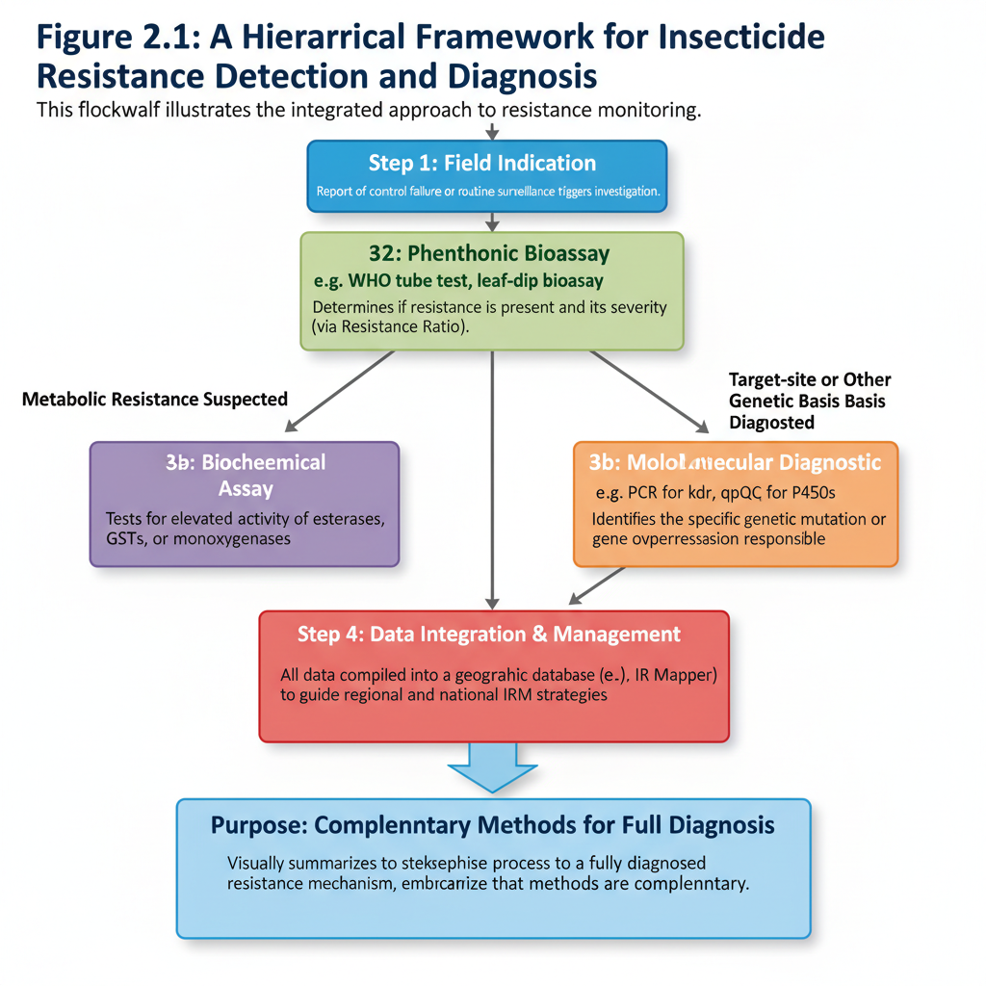

The most transformative advances have come from molecular diagnostics, which allow for precise, early detection long before full-blown control failure occurs. Allele-Specific PCR (AS-PCR) is a workhorse technique for detecting single nucleotide polymorphisms (SNPs) like the kdr mutation. By using primers that are specific to the wild-type (susceptible) or mutant (resistant) allele, it is possible to genotype individual insects and determine the exact frequency of resistance alleles in a population. For metabolic resistance mediated by gene overexpression, quantitative PCR (qPCR) is used to measure the transcript levels of key detoxification genes (e.g., CYP6 P450s), comparing their expression in resistant versus susceptible strains.
Moving beyond targeted approaches, Next-Generation Sequencing (NGS) offers a hypothesis-free path to discovery. RNA-Seq can sequence the entire transcriptome, revealing all genes that are up- or down-regulated in a resistant strain, potentially uncovering novel resistance mechanisms. Whole Genome Sequencing (WGS) can identify mutations anywhere in the genome, linking them to resistance phenotypes. The challenge with NGS is the cost and computational bioinformatics required, but it represents the future of comprehensive resistance diagnosis.
2.4 Effects of Insecticide Resistance
The evolution and spread of insecticide resistance trigger a cascade of negative consequences that extend far beyond a simple failure of chemical control. Its effects permeate agricultural systems, public health programs, economic structures, and the environment, creating a complex and escalating global challenge.

2.4.1 Agricultural and Economic Effects
The most immediate impact of resistance is felt in agricultural production. When insecticides fail, crop losses to pest infestations increase substantially. This directly translates to reduced yields and lower-quality produce, threatening food security at both local and national levels (Godfray et al., 2016). Farmers, facing control failures, often respond by increasing the frequency, rate, and number of insecticide applications. This leads to a vicious cycle of rising production costs without a corresponding increase in yield or profit, pushing farmers, particularly smallholders, into debt and exacerbating rural poverty (Sparks, 2021).
The economic burden extends beyond the farm gate. The increased cost of production contributes to higher food prices for consumers. Furthermore, the agricultural industry and public sectors face massive costs associated with researching and developing new insecticide chemistries, a process that is both time-consuming and prohibitively expensive, often exceeding $250 million per new product (Sparks & Nauen, 2015). This diminishing return on investment can discourage agrochemical companies from investing in new modes of action, thereby shrinking the available toolkit for future pest management.
2.4.2 Public Health Implications
Insecticide resistance poses a grave threat to global public health by undermining the control of deadly vector-borne diseases. The efficacy of insecticides is a cornerstone of malaria control, primarily through Long-Lasting Insecticidal Nets (LLINs) and Indoor Residual Spraying (IRS), which rely heavily on pyrethroids. The spread of pyrethroid resistance in Anopheles mosquitoes has been directly linked to a resurgence of malaria cases in several African countries, threatening to reverse decades of hard-won progress (Bhatt et al., 2015). Similarly, resistance in Aedes aegypti mosquitoes compromises efforts to control outbreaks of dengue, chikungunya, and Zika virus, leaving populations vulnerable with fewer effective intervention tools (Hemingway et al., 2016).
2.4.3 Environmental Consequences
The struggle against resistance has significant unintended environmental consequences. As farmers and health officials apply more insecticides to overcome failing efficacy, the total environmental load of these chemicals increases. This leads to greater contamination of soil and water resources, harming non-target organisms, including pollinators like bees, aquatic insects, and beneficial natural enemies that provide biological pest control (Pisa et al., 2015). The loss of these beneficial species can further destabilize agroecosystems, leading to secondary pest outbreaks and creating an even greater reliance on chemicals—a phenomenon known as the "pesticide treadmill."
2.4.4 Societal and Operational Impacts
The erosion of trust in chemical control methods can lead to societal friction. Farmers may lose confidence in recommended pest management practices, and communities may become disillusioned with public health interventions that appear to be failing. Operationally, resistance forces disease control programs to shift to more expensive and logistically complex insecticides, straining limited public health budgets (WHO, 2012). It also complicates emergency responses to pest outbreaks, as first-line chemical defenses may no longer be reliable, leading to delayed and less effective control measures.
The ramifications of insecticide resistance extend far beyond a simple failure of chemical control, creating a cascade of detrimental effects that cripple agricultural productivity, undermine public health victories, inflict severe economic damage, and degrade environmental quality. Understanding this domino effect is crucial to appreciating the full scope of the resistance crisis.
The Agricultural Vicious Cycle: From Control Failure to Economic Ruin
The most immediate impact is observed in the field. A confirmed resistance incident initiates a destructive feedback loop. Faced with control failure, a farmer's typical response is to increase the frequency, dosage, and number of insecticide applications. This "more of the same" approach escalates production costs significantly sometimes by over 50%—without a guaranteed increase in yield. The result is a drastic reduction in profit margins, pushing smallholder farmers, in particular, into debt and vulnerability (Sparks, 2021). This cycle, often called the "pesticide treadmill," is difficult to escape. The increased chemical load also heightens the risk of pesticide residue violations on food, leading to market rejections and further economic loss for entire agricultural sectors.
Public Health at Risk: The Resurgence of Vector-Borne Diseases
In public health, the stakes are measured in human lives. The massive gains achieved in reducing malaria incidence through Long-Lasting Insecticidal Nets (LLINs) and Indoor Residual Spraying (IRS) are critically dependent on the efficacy of pyrethroids. The rapid spread of pyrethroid resistance in Anopheles mosquitoes across Africa has been statistically linked to the resurgence of malaria cases and deaths in several regions, threatening to reverse a decades-long war of attrition (Bhatt et al., 2015). Similarly, resistance in Aedes aegypti to commonly used adulticides like malathion and permethrin has hampered emergency responses to dengue and Zika outbreaks, leaving public health officials with dwindling options to protect communities.
The Environmental Toll: Harming Allies and Polluting Ecosystems
The struggle against resistance has severe unintended environmental consequences. The increased volume and frequency of insecticide applications lead to greater runoff into water bodies and persistent soil contamination. This directly harms non-target organisms, including:
Pollinators: Bees and other beneficial insects are decimated, threatening the pollination of both crops and wild plants.
Natural Enemies: Predatory beetles, parasitoid wasps, and spiders are often more susceptible to insecticides than the pests themselves. Their elimination triggers secondary pest outbreaks, where previously minor pests explode in number due to the lack of natural control.
Aquatic Life: Fish and other aquatic fauna are highly vulnerable to insecticide contamination, disrupting entire freshwater ecosystems.
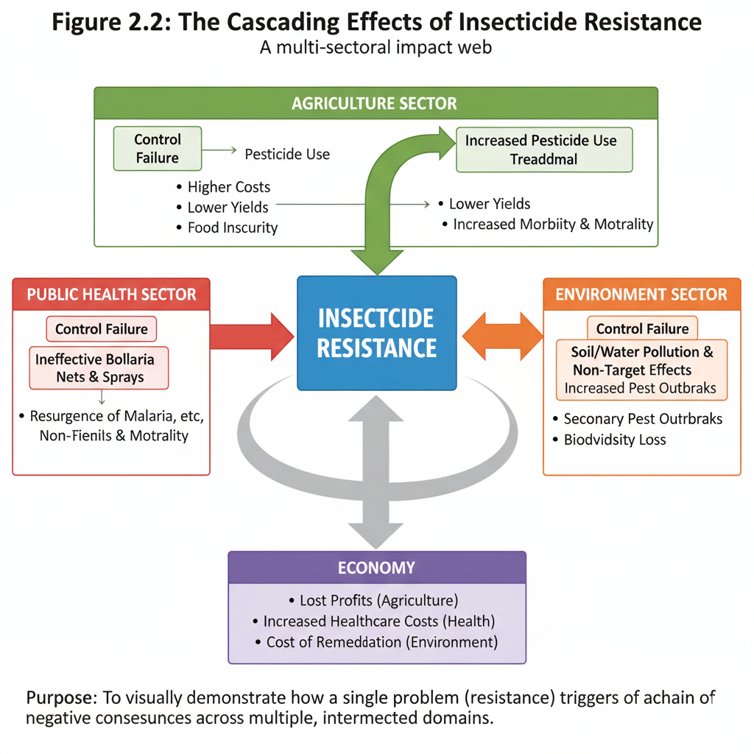
Beyond the direct costs, resistance imposes a heavy burden on national economies and long-term development. Health ministries must divert limited funds to more expensive alternative insecticides and complex control programs. Nations may face reduced agricultural exports due to quarantine restrictions or residue issues, affecting foreign exchange earnings. On a household level, money spent on ineffective insecticides is money not spent on education, nutrition, or healthcare. Furthermore, the psychological stress on farmers dealing with recurrent crop losses and the anxiety in communities facing recurrent disease outbreaks represent significant, though often unquantified, social costs that hinder overall community resilience and development.
In summary, the effects of insecticide resistance are not isolated to the field or the laboratory. They create a negative feedback loop that jeopardizes food production, endangers human health, degrades ecosystems, and imposes severe economic strains. This multifaceted impact underscores the critical urgency of developing and implementing sustainable resistance management strategies to protect global health and prosperity.
2.5 Management Strategies for Insecticide Resistance
Combating insecticide resistance requires a proactive, strategic, and multi-faceted approach known as Insecticide Resistance Management (IRM). The core principle of IRM is to reduce the selection pressure for resistance genes while maintaining effective pest control, thereby preserving the susceptibility of pest populations and the useful life of existing insecticides. Effective IRM is not a single tactic but an integrated framework of complementary strategies.
The cornerstone of most IRM programs is the practice of insecticide rotation. This strategy involves sequentially using insecticides from different, unrelated chemical classes that have no cross-resistance. The rationale is that a resistance genotype selected by one insecticide will confer a fitness cost or, at minimum, no advantage when a different insecticide with a distinct mode of action is applied. This prevents any single resistance mechanism from becoming fixed in the population (Sparks & Nauen, 2015). For rotation to be successful, the alternated insecticides must be equally effective and the switch must occur before resistance frequencies become too high, guided by robust monitoring data.
A more complex but potentially powerful strategy is the use of insecticide mixtures. This involves applying two or more insecticides with different modes of action in a single formulation or tank mix. The theory is that an individual insect resistant to one insecticide will be killed by the other, making the inheritance of resistance to multiple compounds functionally recessive (Roush, 1998). This "redundant killing" action can be highly effective, but it carries risks. If resistance to one component already exists at a moderate frequency, the mixture can act as a "selection filter" for multiple-resistance, rapidly creating a pest population resistant to all components simultaneously. Therefore, mixtures are best deployed proactively, using fully effective insecticides.
The concept of refuges is a critical ecological and genetic component of IRM, particularly in the context of transgenic Bt crops. A refuge is an area of a crop field that is left untreated or planted with a non-Bt variety. This sanctuary maintains a population of susceptible insects that can randomly mate with any resistant survivors from the treated area. By diluting the resistance genes in the general gene pool, refuges help to keep resistance recessive and delay its evolution (Gould, 1998). The strategic design and placement of refuges are essential for their success and are a mandated part of IRM plans for Bt crops in many countries.
Beyond chemical tactics, the most sustainable long-term approach is the full adoption of Integrated Pest Management (IPM). IPM is a holistic ecosystem-based strategy that promotes the use of a wide range of complementary control methods. This includes biological control through the conservation and introduction of natural enemies (parasitoids, predators, and pathogens), cultural control such as crop rotation, intercropping, and adjusting planting dates to disrupt pest life cycles, and the use of physical methods like traps and pheromone-based mating disruption (Dara, 2019). By reducing reliance on insecticides as the sole control method, IPM decreases the overall selection pressure for resistance.
Technological innovation offers promising new frontiers for IRM. The development of insecticides with novel modes of action is the most direct solution, though the discovery pipeline has slowed considerably. Alternatives such as RNA interference (RNAi) technology, which uses sprayable double-stranded RNA to silence essential genes in target pests, represent a new class of biorational insecticides with a high specificity and a potentially lower risk of cross-resistance (Zotti et al., 2018). Furthermore, precision agriculture technologies, including drones and sensor-based application systems, allow for targeted insecticide use only where and when pest densities exceed economic thresholds, minimizing unnecessary chemical exposure and selection pressure.
The success of any IRM strategy is fundamentally dependent on education, monitoring, and regulation. Farmers, applicators, and public health workers must be educated on the principles of resistance and the importance of adhering to IRM guidelines. This is supported by continuous resistance monitoring, as detailed in Section 2.3, to provide the data needed to make informed decisions about which insecticides to use or rotate. Finally, strong regulatory frameworks are essential. Government agencies must enforce sensible regulations on insecticide registration, label instructions that mandate IRM practices, and the phased withdrawal of compounds to which high-level resistance is widespread.
The relentless evolution of insecticide resistance necessitates a shift from reactive control failures to proactive, strategic management. Insecticide Resistance Management (IRM) is a structured approach designed to delay the onset and reduce the magnitude of resistance by minimizing selection pressure while maintaining effective pest control. A successful IRM program is not a single tactic but an integrated framework that combines chemical, genetic, biological, and cultural strategies in a synergistic manner (Sparks & Nauen, 2015).
The Core Chemical Strategies: Rotation, Mixtures, and Mosaics
The tactical use of insecticides is the first line of defense in IRM. Insecticide rotation involves alternating between compounds from different Mode of Action (MoA) groups, ensuring that each generation of pests is exposed to a different selective agent. This strategy is effective because it prevents the consistent selection for a single resistance mechanism. For rotation to be successful, the alternated insecticides must have no cross-resistance and should be switched before resistance allele frequencies become high (Gould et al., 2018). A more complex but potent strategy is the use of insecticide mixtures, which involves applying two or more insecticides with distinct MoAs simultaneously. The theoretical foundation is that the probability of an individual insect possessing resistance mechanisms to all components in the mixture is exceedingly low, leading to "redundant killing" (Roush, 1998). However, this approach carries the risk of selecting for multiple-resistance if one component begins to fail, and it is most effective when all components remain highly efficacious. A related spatial strategy is the insecticide mosaic, where different insecticides are applied to different sections of a field or area. This creates a heterogeneous selection landscape, though its practical implementation can be challenging.
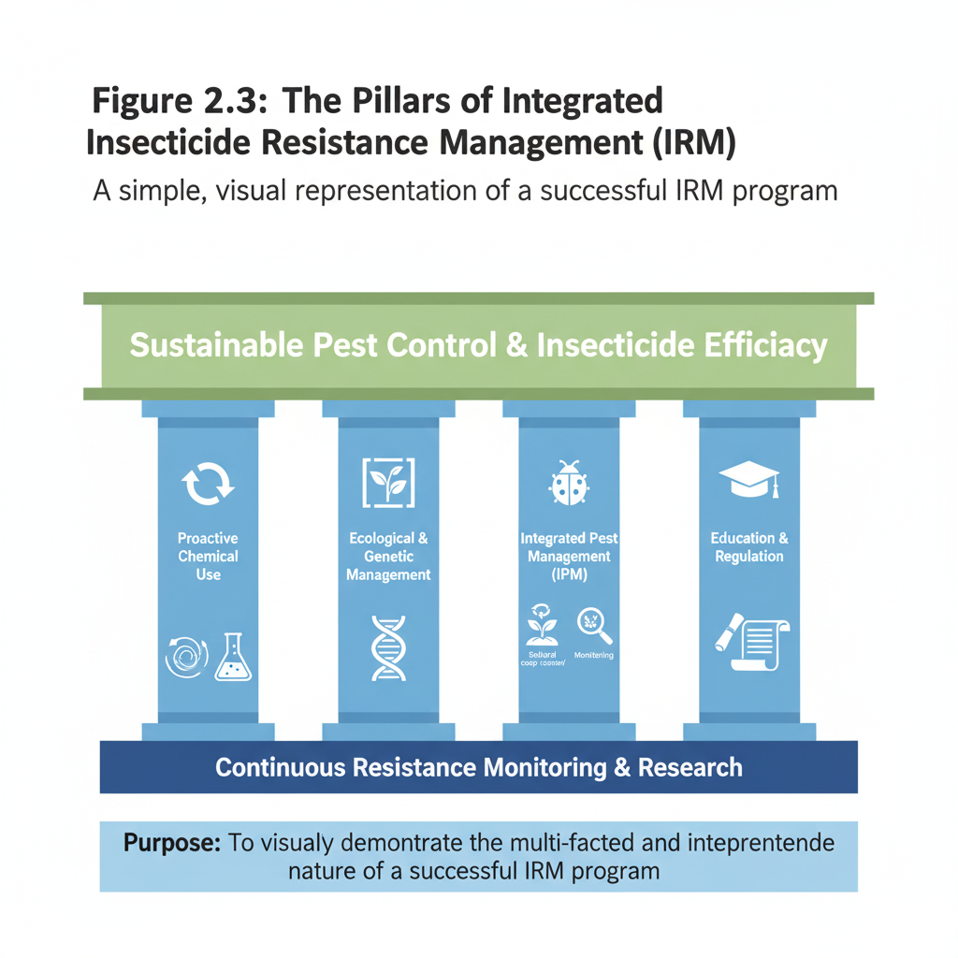
The Ecological and Genetic Backbone: The Refuge Strategy
A cornerstone of IRM, particularly for transgenic Bt crops, is the high-dose/refuge strategy. This approach involves planting a portion of the field with a non-Bt crop (the "refuge") to maintain a large population of susceptible insects. These susceptible individuals mate with the rare resistant survivors from the Bt crop, producing heterozygous offspring that are killed by the high dose of the Bt toxin, thereby keeping resistance alleles rare and recessive in the population (Gould, 1998). The mandated implementation of this strategy has been instrumental in delaying resistance in major pests like the corn borer for over two decades, showcasing the power of applied evolutionary principles (Tabashnik et al., 2013).
Beyond Chemicals: The Overarching Framework of IPM
The most sustainable approach to mitigating resistance is to reduce reliance on insecticides altogether through Integrated Pest Management (IPM). IPM is an ecosystem-based strategy that uses a combination of techniques:
Biological Control: The conservation and introduction of natural enemies (parasitoids, predators, and pathogens) to suppress pest populations (Van Lenteren, 2012).
Cultural Control: Practices such as crop rotation, intercropping, manipulation of planting dates, and field sanitation to disrupt pest life cycles and make the environment less favorable (Dara, 2019).
Behavioral Control: Using pest attractants or repellents, such as pheromone traps for mating disruption.
Genetic Control: Planting pest-resistant crop varieties.
By using insecticides only as a last resort when pest populations exceed an economic threshold, IPM drastically reduces the selection pressure that drives resistance (Peterson et al., 2018).
The Enabling Pillars: Monitoring, Education, and Regulation
The technical strategies above are ineffective without robust support systems. Continuous resistance monitoring, as detailed in Section 2.3, provides the essential data to make informed IRM decisions, allowing for dynamic and adaptive management (Hemingway et al., 2016). Furthermore, farmer and community education is critical to ensure the correct implementation of complex strategies like rotation and refuges. Finally, strong regulatory frameworks are needed to enforce IRM guidelines, manage the registration and withdrawal of insecticides, and promote the development of new, lower-risk tools through policy incentives (WHO, 2012). A successful IRM program, therefore, relies on the seamless integration of science, education, and policy.
In conclusion, there is no single "silver bullet" for managing insecticide resistance. A successful, durable IRM program is a dynamic and integrated system. It must intelligently combine chemical rotation and mixtures, leverage the power of refuges, and be firmly embedded within a broader IPM context. This strategy must be continuously informed by vigilant monitoring, supported by farmer education, and reinforced by sensible regulations. Only through such a comprehensive and collaborative effort can we hope to win the evolutionary arms race and secure the future of pest management.
2.6 Conclusion of Literature Review
The extensive body of literature on insecticide resistance paints a clear and urgent picture: the ability of insect pests to evolve resistance is a formidable and persistent challenge that threatens global food security, public health, and ecological balance. This review has synthesized the key facets of this complex issue, tracing the journey from the historical reliance on insecticides to the current understanding of resistance as a dynamic evolutionary process.
The evidence confirms that resistance is not a singular event but a multi-faceted phenomenon driven by a combination of operational missteps, inherent biological capabilities of insects, and broader ecological factors. The mechanisms—ranging from metabolic detoxification and target-site mutations to behavioral avoidance—demonstrate the remarkable adaptability of insect pests under intense selection pressure. This adaptability is further complicated by the prevalence of multiple resistance, where several mechanisms operate concurrently, rendering many conventional insecticides ineffective.
Crucially, the literature underscores that the battle against resistance is not futile. The development of sophisticated detection tools, from traditional bioassays to cutting-edge molecular diagnostics, provides the necessary intelligence to monitor resistance alleles and understand their spread in real-time. This knowledge is the bedrock upon which effective Insecticide Resistance Management (IRM) must be built. The reviewed management strategies, including insecticide rotation, mixtures, the use of refuges, and the overarching framework of Integrated Pest Management (IPM), offer a viable path forward. These strategies are not standalone solutions but are most powerful when deployed in a coordinated and synergistic manner.
However, the literature also reveals critical gaps and future directions. The pace of discovering novel insecticide modes of action remains alarmingly slow, and the implementation of IRM strategies is often inconsistent due to economic, educational, and logistical barriers. There is a pressing need for more region-specific resistance monitoring data, the development of rapid, field-deployable diagnostic kits, and a greater investment in alternative control tactics such as biological control and biopesticides. Ultimately, the scholarly consensus points to the undeniable necessity of a proactive, knowledge-based, and globally coordinated approach to outmaneuver resistance and preserve the efficacy of our pest management tools for future generations.

CHAPTER THREE
3.0 Conclusion and Recommendation
3.1 Conclusion
The escalating challenge of insecticide resistance stands as a formidable testament to the adaptive prowess of insect pests in the face of intense anthropogenic selection pressure. This seminar has systematically explored the multifaceted dimensions of this crisis, from its underlying causes and complex genetic and biochemical mechanisms to its far-reaching effects and the strategies required for its mitigation. It is unequivocally clear that insecticide resistance is not a mere agronomic inconvenience but a profound threat to global food security, public health, economic stability, and environmental integrity.
The persistence and spread of resistance are direct consequences of a historical over-reliance on chemical control, often characterized by injudicious insecticide use, a lack of rotation, and the absence of integrated approaches. Insects have responded through an arsenal of defense mechanisms, including metabolic detoxification, target-site insensitivity, and behavioral adaptations, often deploying them in combination to survive chemical assaults. The effects of this resistance are catastrophic, leading to crop devastation, the resurgence of vector-borne diseases, increased production costs, and environmental degradation.
However, this seminar also affirms that the situation is not hopeless. The development of advanced diagnostic tools, particularly molecular techniques, provides an unprecedented ability to detect and monitor resistance in its incipient stages. Furthermore, a robust framework for management exists, centered on the principles of Insecticide Resistance Management (IRM) and Integrated Pest Management (IPM). Strategies such as the tactical rotation of insecticide classes, the strategic use of refuges, and the promotion of biological and cultural controls offer a sustainable path forward. The key to success lies in moving from a reactive to a proactive stance, using knowledge and surveillance to outmaneuver the evolutionary capabilities of pest populations. Ultimately, preserving the efficacy of current and future insecticide tools is imperative, demanding a concerted, global, and interdisciplinary effort.
3.2 Recommendation
Based on the findings and conclusions of this seminar, the following recommendations are proposed to effectively combat the menace of insecticide resistance:
- Strengthen and Standardize Resistance Monitoring Programs: Governments and agricultural agencies should establish and fund national-scale, standardized surveillance systems for major crop pests and disease vectors. This should integrate traditional bioassays with cost-effective molecular diagnostics to track resistance allele frequencies and provide real-time data to farmers and public health officials.
- Promote Widespread Adoption of Integrated Pest Management (IPM): Extension services and policy makers must actively encourage and subsidize the adoption of IPM. This includes training farmers on the use of biological control agents, cultural practices (like crop rotation and sanitation), and the use of insecticides only as a last resort based on established economic thresholds.
- Implement Mandatory Insecticide Resistance Management (IRM) Strategies: Regulatory bodies should enforce IRM guidelines as a condition for insecticide registration. This includes mandating clear label instructions for insecticide rotation (based on MoA groups) and, where applicable, the establishment of structured refuges for pests targeted by transgenic Bt crops.
- Invest in Research and Development (R&D): Increased public and private investment is crucial for R&D into novel insecticide modes of action, bio-rational pesticides (e.g., RNAi-based products, microbial insecticides), and precision application technologies that minimize off-target effects and reduce selection pressure.
- Enhance Farmer and Public Education: Launch comprehensive awareness campaigns to educate farmers on the economic and ecological costs of resistance and the proper use of IRM strategies. Simultaneously, public health campaigns should inform communities about the importance of insecticide resistance in disease control to foster support for vector management programs.
- Enact Supportive Policies and Global Collaboration: Governments should develop policies that incentivize sustainable farming practices and provide safety nets for farmers during the transition to IPM. Furthermore, international collaboration under a "One Health" framework is essential to monitor the cross-border spread of resistance and coordinate management efforts, particularly for migratory pests and disease vectors.

REFERENCES
Balabanidou, V., Grigoraki, L., Vontas, J. (2018). Insect cuticle: a critical determinant of insecticide resistance. Current Opinion in Insect Science, 27, pp. 68- 74, 10.1016/j.cois.2018.03.004
Bass, C., Puinean, A.M., Zimmer, C.T., Denholm, I., Field, L.M., Foster, S.P., Gutbrod, O., Nauen, R., Slater, R., Williamson, M.S. (2014). The evolution of insecticide resistance in the peach potato aphid, Myzus persicae. Insect Biochemistry and Molecular Biology, 51, pp. 41- 51, 10.1016/j.ibmb.2014.05.003
Bhatt, S., Weiss, D.J., Cameron, E., Bisanzio, D., Mappin, B., Dalrymple, U., Battle, K.E., Moyes, C.L., Henry, A., Eckhoff, P.A., Wenger, E.A., Briet, O., Penny, M.A., Smith, T.A., Bennett, A., Yukich, J., Eisele, T.P., Griffin, J.T., Fergus, C.A., Lynch, M., Lindgren, F., Cohen, J.M., Murray, C.L.J., Smith, D.L., Hay, S.I., Cibulskis, R.E., Gething, P.W. (2015). The effect of malaria control on Plasmodium falciparum in Africa between 2000 and 2015. Nature, 526(7572), pp. 207-211, 10.1038/nature15535
Dara, S.K. (2019). The new integrated pest management paradigm for the modern age. Journal of Integrated Pest Management, 10(1), 12, 10.1093/jipm/pmz010
David, J.P., Strode, C., Vontas, J., Nikou, D., Vaughan, A., Pignatelli, P.M., Louis, C., Hemingway, J., Ranson, H. (2005). The Anopheles gambiae detoxification chip: A highly specific microarray to study metabolic-based insecticide resistance in malaria vectors. Proceedings of the National Academy of Sciences, 102(11), pp. 4080-4084, 10.1073/pnas.0409348102
Dong, K., Du, Y., Rinkevich, F., Nomura, Y., Xu, P., Wang, L., Silver, K., Zhorov, B.S. (2014). Molecular biology of insect sodium channels and pyrethroid resistance. Insect Biochemistry and Molecular Biology, 50, pp. 1- 17, 10.1016/j.ibmb.2014.03.012
Faucon, F., Dusfour, I., Gaude, T., Navratil, V., Boyer, F., Chandre, F., Sirisopa, P., Thanispong, K., Juntarajumnong, W., Poupardin, R., Chareonviriyaphap, T., Girod, R., Corbel, V., Reynaud, S., David, J.P. (2015). Identifying genomic changes associated with insecticide resistance in the dengue mosquito Aedes aegypti by deep targeted sequencing. Genome Research, 25(9), pp. 1347- 1359, 10.1101/gr.189225.115
Feyereisen, R. (2012). Insect CYP genes and P450 enzymes. In Insect Molecular Biology and Biochemistry, Elsevier, pp. 236-316, 10.1016/B978-0-12- 384747-8.10008-X
ffrench-Constant, R.H. (2013). The molecular genetics of insecticide resistance. Genetics, 194(4), pp. 807-815, 10.1534/genetics.113.151324
Fukuto, T.R. (1990). Mechanism of action of organophosphorus and carbamate insecticides. Environmental Health Perspectives, 87, pp. 245- 254, 10.1289/ehp.9087245
Gatton, M.L., Chitnis, N., Churcher, T., Donnelly, M.J., Ghani, A.C., Godfray, H.C.J., Gould, F., Hastings, I., Marshall, J., Ranson, H., Rowland, M., Shaman, J., Lindsay, S.W. (2013). The importance of mosquito behavioural adaptations to malaria control in Africa. Evolution, 67(4), pp. 1218-1230, 10.1111/evo.12063
Godfray, H.C.J., Mason-D’Croz, D., Robinson, S. (2016). Food system consequences of a fungal disease epidemic in a major crop. Philosophical Transactions of the Royal Society B: Biological Sciences, 371(1709), 20150467, 10.1098/rstb.2015.0467
Gould, F. (1998). Sustainability of transgenic insecticidal cultivars: integrating pest genetics and ecology. Annual Review of Entomology, 43, pp. 701- 726, 10.1146/annurev.ento.43.1.701
Gould, F., Brown, Z.S., Kuzma, J. (2018). Wicked evolution: Can we address the sociobiological dilemma of pesticide resistance? Science, 360(6390), pp. 728- 732, 10.1126/science.aar3780
Hancock, P.A., Hendriks, C.J.M., Tangena, J.A., Gibson, H., Hemingway, J., Coleman, M., Gething, P.W., Cameron, E., Bhatt, S., Moyes, C.L. (2020). Mapping trends in insecticide resistance phenotypes in African malaria vectors. PLOS Biology, 18(6), e3000633, 10.1371/journal.pbio.3000633
Hemingway, J., Hawkes, N.J., McCarroll, L., Ranson, H. (2004). The molecular basis of insecticide resistance in mosquitoes. Insect Biochemistry and Molecular Biology, 34(7), pp. 653-665, 10.1016/j.ibmb.2004.03.018
Hemingway, J., Ranson, H., Magill, A., Kolaczinski, J., Fornadel, C., Gimnig, J., Coetzee, M., Simard, F., Roch, D.K., Hinzoumbe, C.K., Pickett, J., Schellenberg, D., Gething, P., Hoppé, M., Hamon, N. (2016). Averting a malaria disaster: will insecticide resistance derail malaria control? The Lancet, 387(10029), pp. 1785-1788, 10.1016/S0140-6736(15)00417-1
Jeschke, P., Nauen, R., Schindler, M., Elbert, A. (2011). Overview of the status and global strategy for neonicotinoids. Journal of Agricultural and Food Chemistry, 59(7), pp. 2897-2908, 10.1021/jf101303g
Martinez-Torres, D., Chandre, F., Williamson, M.S., Darriet, F., Bergé, J.B., Devonshire, A.L., Guillet, P., Pasteur, N., Pauron, D. (1998). Molecular characterization of pyrethroid knockdown resistance (kdr) in the major malaria vector Anopheles gambiae s.s. Insect Molecular Biology, 7(2), pp. 179- 184, 10.1046/j.1365-2583.1998.72062.x
Pan, Y., Zhu, E., Gao, X., Zhou, L., Zhang, L., Xi, J., Zeng, X., Luo, J. (2021). A novel insecticidal peptide Sf1a from the venom of Scolopendra subspinipes mutilans inhibits insect voltage-gated sodium channels. Toxicon, 201, pp. 38- 45, 10.1016/j.toxicon.2021.08.005
Peterson, R.K.D., Varella, A.C., Higley, L.G. (2018). Tolerance: the forgotten child of plant resistance. PeerJ, 6, e5484, 10.7717/peerj.5484
Pisa, L.W., Amaral-Rogers, V., Belzunces, L.P., Bonmatin, J.M., Downs, C.A., Goulson, D., Kreutzweiser, D.P., Krupke, C., Liess, M., McField, M., Morrissey, C.A., Noome, D.A., Settele, J., Simon-Delso, N., Stark, J.D., Van der Sluijs, J.P., Van Dyck, H., Wiemers, M. (2015). Effects of neonicotinoids and fipronil on non-target invertebrates. Environmental Science and Pollution Research, 22(1), pp. 68-102, 10.1007/s11356-014-3471-x
Roush, R.T. (1998). Two–toxin strategies for management of insecticidal transgenic crops: can pyramiding succeed where pesticide mixtures have not? Philosophical Transactions of the Royal Society of London. Series B: Biological Sciences, 353(1376), pp. 1777-1786, 10.1098/rstb.1998.0330
Soderlund, D.M. (2012). Molecular mechanisms of pyrethroid insecticide neurotoxicity: recent advances. Archives of Toxicology, 86(2), pp. 165- 181, 10.1007/s00204-011-0726-x
Sparks, T.C. (2021). Insecticide discovery: an evaluation and analysis. Pesticide Biochemistry and Physiology, 107-124, 10.1016/j.pestbp.2021.104925
Sparks, T.C., Nauen, R. (2015). IRAC: Mode of action classification and insecticide resistance management. Pesticide Biochemistry and Physiology, 121, pp. 122- 128, 10.1016/j.pestbp.2014.11.014
Tabashnik, B.E., Brévault, T., Carrière, Y. (2013). Insect resistance to Bt crops: lessons from the first billion acres. Nature Biotechnology, 31(6), pp. 510- 521, 10.1038/nbt.2597
Van Lenteren, J.C. (2012). The state of commercial augmentative biological control: plenty of natural enemies, but a frustrating lack of uptake. BioControl, 57(1), pp. 1-20, 10.1007/s10526-011-9395-1
Vontas, J., Kioulos, E., Pavlidi, N., Morou, E., della Torre, A., Ranson, H. (2012). Insecticide resistance in the major dengue vectors Aedes albopictus and Aedes aegypti. Pesticide Biochemistry and Physiology, 104(2), pp. 126- 131, 10.1016/j.pestbp.2012.05.008
Weill, M., Lutfalla, G., Mogensen, K., Chandre, F., Berthomieu, A., Berticat, C., Pasteur, N., Philips, A., Fort, P., Raymond, M. (2003). Insecticide resistance in mosquito vectors. Nature, 423(6936), pp. 136-137, 10.1038/423136b
World Health Organization (WHO). (2012). Global plan for insecticide resistance management in malaria vectors. World Health Organization.
World Health Organization (WHO). (2016). Test procedures for insecticide resistance monitoring in malaria vector mosquitoes (2nd ed.). World Health Organization.
Zotti, M.J., Smagghe, G. (2018). RNAi technology for insect management and protection of beneficial insects from diseases: lessons, challenges and risk assessments. Neotropical Entomology, 47(1), pp. 1-11, 10.1007/s13744-017- 0567-2

